**Chapter 1 : Develop Azure Computer Solutions(~~20-25~~25-30%)**

**Section 1: Implement IaaS solutions**

**Provisioning VM’s:**

Server Provisioning is defining sever configuration based on the user requirements

Such as

* H/W [CPU, Storage, RAM, N/W, etc.]
* OS [Operating System]
* Application

**----------------------------------------------------------------------------------------------------------------------------------------------------------------------------------------------------------------------------------------------------**

**VM Provisioning Life Cycle:**

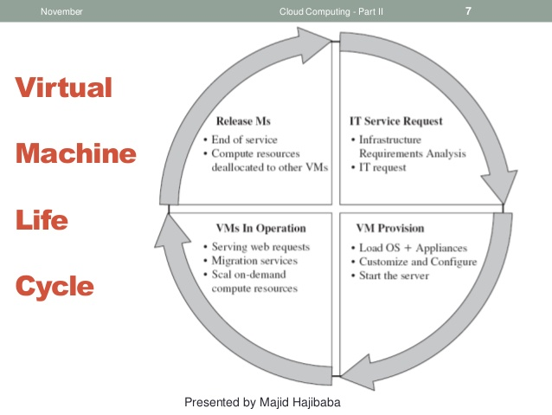

**IT Service Request:** Requirement Analysis

**VM Provision:** Load OS, Applications and Configuration

**VM In Operation:** Running & Providing Services

**Release VMs:** Deallocate Resources

**----------------------------------------------------------------------------------------------------------------------------------------------------------------------------------------------------------------------------------------------------**

**Configure VMs for remote access:**

**To Configure a VM for direct RDP Access:**

Run an **RDP** server or use built-in options to **enable Remote Desktop** for all users on the **System.** Example: Enabling remote connections in Windows 7 and Windows 2008 R2. Click Start, and then right-click **Computer**.

Verify that port 3389 is open on the **VM** operating **system** firewall.

**Enable Remote Management:**

In Server Manager, Click Local Server-> **Remote** management current setting (disabled).

Select **Enable Remote** management for this server.

Click OK.

**Prepare Your Virtual Machines for Remote Desktop:**

* Install **Remote Desktop Services Components** on physical servers or on virtual machines.
* Create **Windows Sever Virtual Machine in Azure**
* Create **three VMs** like following:
  + RD Session Host
  + Connection Broker
  + RD Web and RD Gateway
* Ensure the availability of your RDS deployment, create an availability set (under **High availability** in the VM Creation Process**)** and group multiple VMs in the availability Set.
* Connect to the virtual machine using the Remote Desktop Connection (RDC) client:
* In the Azure portal open the Resource groups view, and then click the resource group to use for the deployment.
* Select a new RDSH virtual machine (for example, Contoso-Sh1)
* Click **Connect -> Open** to open the Remote Desktop Client.
* In the client, click **Connect**, and then click **Use another user account.** Enter the user name and password for the local administrator account.
* Click **Yes** When warned about the certificate.

**Enable Remote Management:**

* In Server Manager, Click **Local Server -> Remote Management Current Setting (Disabled)**
* Select **Enable remote management for this server.**
* Click **OK.**

**Optional:**

You can temporarily set Windows Update to not automatically download and install updates. This helps prevent changes and System restarts while you deploy the RDSH Server.

* In Server Manager, Click **Local Server-> Workgroup Current Setting.**
* Click **Change -> Domain,** and then enter the domain name (for example, Contoso.com)
* Enter the domain administrator credentials
* Restart the Virtual Machine.

1. Repeat Steps 1 Through 4 for the **RD Web and GW Virtual Machine**
2. Repeat Steps 1 Through 4 for the **RD Connection Broker Virtual Machine.**
3. Initialize and format the attached disk on the RD Connection Broker Virtual Machine
   1. Connect to the RD Connection Broker Virtual Machine (Step 1 above)
   2. In Server Manager, click **Tools**-> **Computer Management**
   3. Click **Disk Management**
   4. Select the attached disk, then **MBR** (**Mater Boot Record),** and then click **OK.**
   5. In the **New Sample Volume** wizard, accept the default values but provide a applicable name for the **Volume Label** (like Shares)
4. On the RD Connection Broker virtual machine create file shares for the user profile disks and certificates:
   1. Open File Explorer, click **This PC,** and open the disk that you added for file shares.
   2. Click **Home** and **New Folder.**
   3. Enter a name for the user disks folder, for example, **UserDisks.**
   4. Right-click the new folder and the **Properties-> Sharing-> Advanced Sharing**
   5. Select **Share this folder** and click **Permissions**
   6. Select **Everyone,** and then click **Remove.** Now click **Add,** enter **Domain Admins,** and click **OK**.
   7. Select **Allow Full Control,** and then click **OK-> OK-> Close**
   8. Repeat Steps **c to g** to create shared folder for certificates.

**----------------------------------------------------------------------------------------------------------------------------------------------------------------------------------------------------------------------------------------------------**

**Create ARM Templates:**

Azure Resource Manager Templates provide simple and unified way to create and manage your Azure environments for both developers and administrators. With simple JSON files you can deploy your environment in consistent fashion and at great speed.

**What is mean by ARM?**

**ARM –** Azure Resource Manager

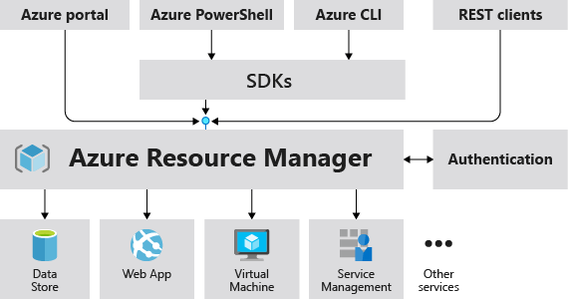

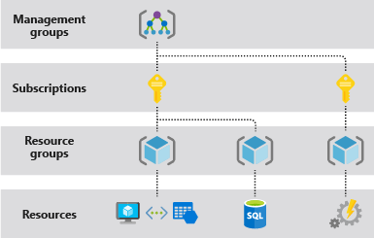

It is a Centralized Resource Management System. It Provides the Following Key Concepts. There are,

* Multiple Deployment Interfaces
* Centralized Layer
* Secured with Azure AD
* Communicates with Resource Providers
* Hierarchical Scope Level
* Unified Language for Resource Management
* Declarative Speech
* Simple Files
* JSON Format
* Standard Properties (Schema, Content Version, parameters, Variables, Resources, Outputs, Functions)
* Multiple Resources Support
* Parameterization of our Templates
* Outputs
* Templated Resource
* The JSON Property “Type” : It Describes what service we are deploying, It is a mandatory field.
* Resource Provider Versions (API Versions – JSON Property)
* Multiple Ways of Deployment

**Key Benefits of ARM Templates:**

* **Infrastructure as Code** (IaC), **Policy** and **Roles** as Code
* **Declarative** Syntax
* **Repeatable** results
* Orchestration
* Built-in Validation
* Modular Files
* Tracked Templates
* Many **Authoring Tools**

**Additional Features of ARM Templates:**

* Functions and Expressions
* Linked and nested templates
* Dependencies
* References
* Export
* Loops
* Conditions

**When to Use ARM Templates:**

* Application Development and Maintenance
* CI/CD scenarios
* Azure governance (Policies, Roles, etc..)

**Tools:** ARM Template Viewer

**Create Container Images for Solutions by using Docker:**

**What is Docker?**

**Developer Says:** It works on my machine

**Customer/Production Said:** It’s not working for us.

To solve above Debt, “Docker” was Introduced. The Dockers allows us to create containers.

This is called as “**Docker Container”.** The main features of docker is **“Portability”**

The Docker is categorized into 3 main things:

* Client-Side Application Program
* It can also be used as a “Service”, if we deployed it to the server.
* Social Networking Platform

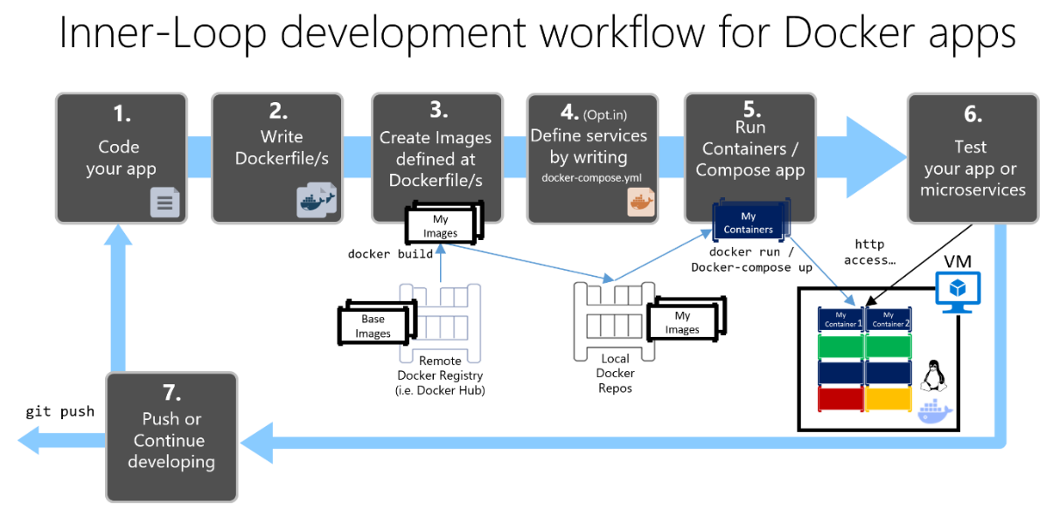

**Docker Container:**

**Docker Container** is an isolated, secured shipping box, which is produced or created when the docker image is run. Docker containers can be run, started, stopped, deleted.

* All of our codes, application information was packed as a container here.
* The **Docker Container** is an Instances of the **Docker Image.**
* We can create **N number of Docker Containers** from the same **Docker Image.**
* It is the blueprint or place where the original application will runs.

It Consists of the following,

* Code Dependencies
* Configuration
* Process
* Networking Information
* O.S (Some Chunks) and More

**Docker Image:**

It is set of Read Only Files. Once a Docker Image is Built, it cannot be modified. Docker Images are used to build the docker containers.

When we run the **Docker Image** with **Docker Run** Command, it produces the output as **Docker Container.**

**Docker Image** is a read only template, composed of layered file system, needed to build a running docker container, basically the running instance of the image.

**Diff Between Docker Image Vs Docker Container:**

Docker Image is a Class

Docker Container is an Object of the Docker Image Class

**Publish an Image to the Azure Container Registry:**

**What is mean by Azure Container Registry?**

**Azure Container Registry** allows you to build, store, and manage **container** images and artifacts in a private **registry** for all types of **container** deployments. Use **Azure Container Registries** with your existing **container** development and deployment pipelines.

